Date: 25-09-21
WEBLEM 3
Introduction to Nucleic Acid Databases

Introduction:

Nucleotide databases that were introduced to us in this weblem were GenBank, EMBL-EBI and DDBJ.

- GenBank:
  - GenBank sequence database is an annotated collection of all publicly available nucleotide sequences and their protein translations.
  - This database is produced at the National Center for Biotechnology Information (NCBI) as part of an international collaboration with the European Molecular Biology Laboratory (EMBL) Data Library from the European Bioinformatics Institute (EBI) and the DNA Data Bank of Japan (DDBJ).
  - GenBank and its collaborators receive sequences produced in laboratories throughout the world from hundreds of thousands of distinct organisms.
  - GenBank continues to grow at an exponential rate, doubling every 18 months.
  - GenBank is built by direct submissions from individual laboratories and from large-scale sequencing centers.
- EMBL-EBI:
  - It makes the world’s public biological data freely available to the scientific community via a range of services and tools, perform basic research and provide professional training in bioinformatics.
  - It is part of the European Molecular Biology Laboratory (EMBL), an international, innovative and interdisciplinary research organisation funded by over 20 member states, prospect and associate member states.
  - It is situated on the Welcome Genome Campus in Hinxton, Cambridge, UK, one of the world’s large.
- DDBJ:
  - DDBJ Center collects nucleotide sequence data as a member of INSDC(International Nucleotide Sequence Database Collaboration) and provides freely available nucleotide sequence data and supercomputer system, to support research activities in life science concentrations of scientific and technical expertise in genomics.
  - The principal purpose of DDBJ operations is to improve the quality of INSD, as public domains. When researchers make their data open to the public through INSD and commonly shared in world wide, we at DDBJ Center make efforts to describe information on the data as rich as possible, according to the unified rules of INSD, preferably without any stress by using DDBJ.

References:
- https://www.ncbi.nlm.nih.gov/books/NBK153518/
- https://www.ebi.ac.uk/about
- https://www.ddbj.nig.ac.jp/about/index-e.html
- https://www.mayoclinic.org/diseases-conditions/klinefelter-syndrome/symptoms-causes/syc-20353949
WEBLEM 3a
Introduction to Nucleic Acid Databases

Aim:

To study the genes involved in the causation of Klinefelter’s syndrome using GenBank Database.

Introduction:

The query taken for Genbank is “Klinefelter’s syndrome”. Klinefelter syndrome is a genetic condition that results when a boy is born with an extra copy of the X chromosome.

Klinefelter syndrome is a genetic condition affecting males, and it often isn't diagnosed until adulthood. Klinefelter syndrome may adversely affect testicular growth, resulting in smaller than normal testicles, which can lead to lower production of testosterone. The syndrome may also cause reduced muscle mass, reduced body and facial hair, and enlarged breast tissue.

The effects of Klinefelter syndrome vary, and not everyone has the same signs and symptoms. About 3% of the infertile male population have Klinefelter syndrome.

Methodology:
- Open Homepage of GenBank (URL-https://www.ncbi.nlm.nih.gov/genbank/)
- Enter Search query (Klinefelter’s syndrome)
- Interpret the result and find the needed data.

Observations:

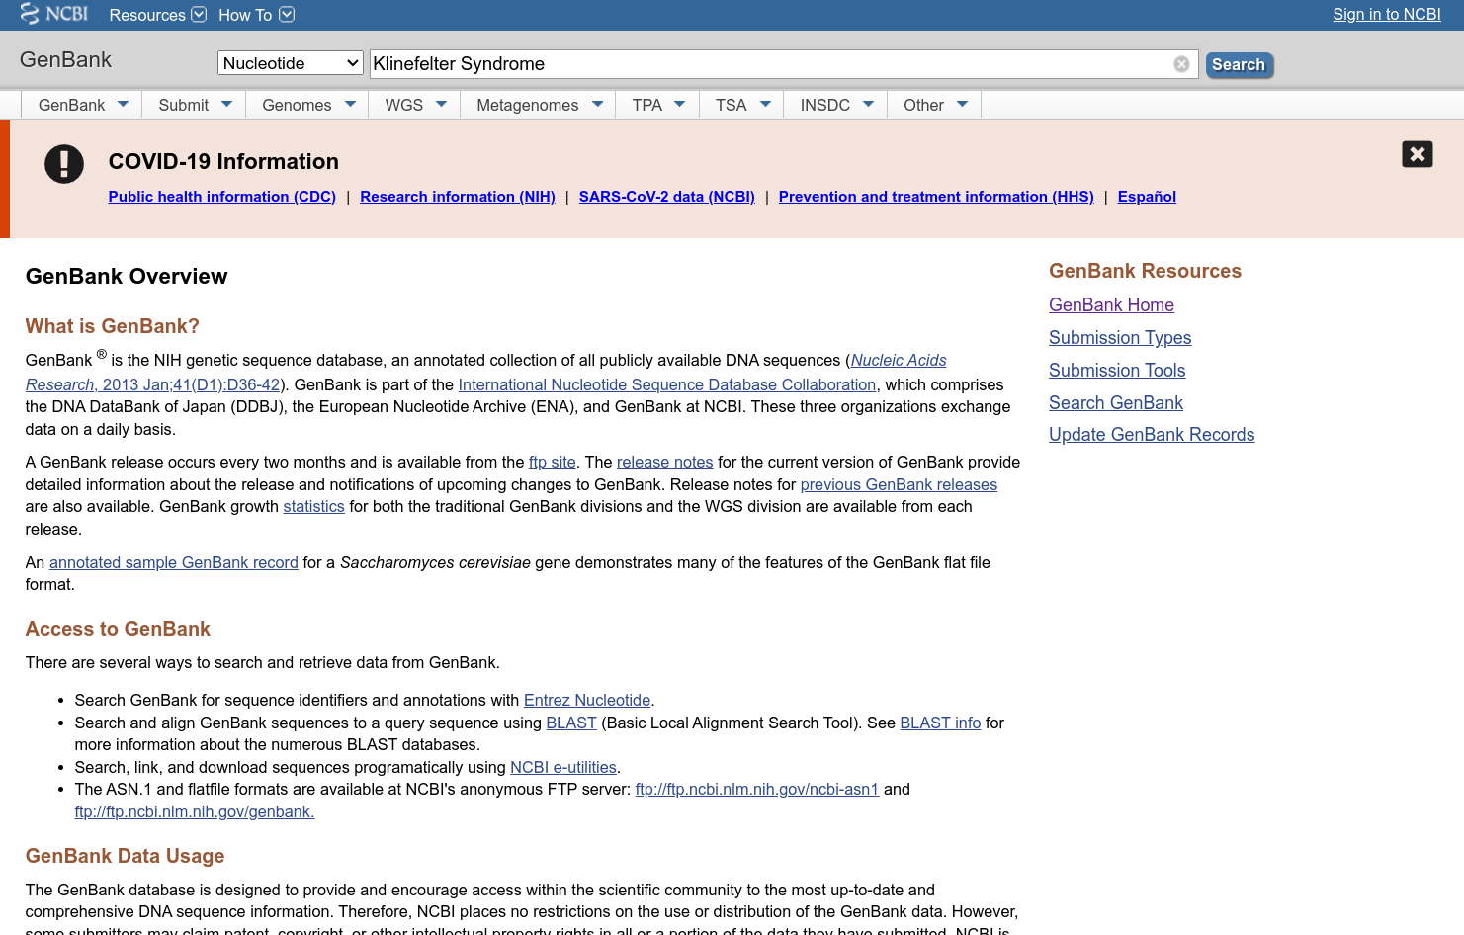

Fig1. Homepage of GenBank
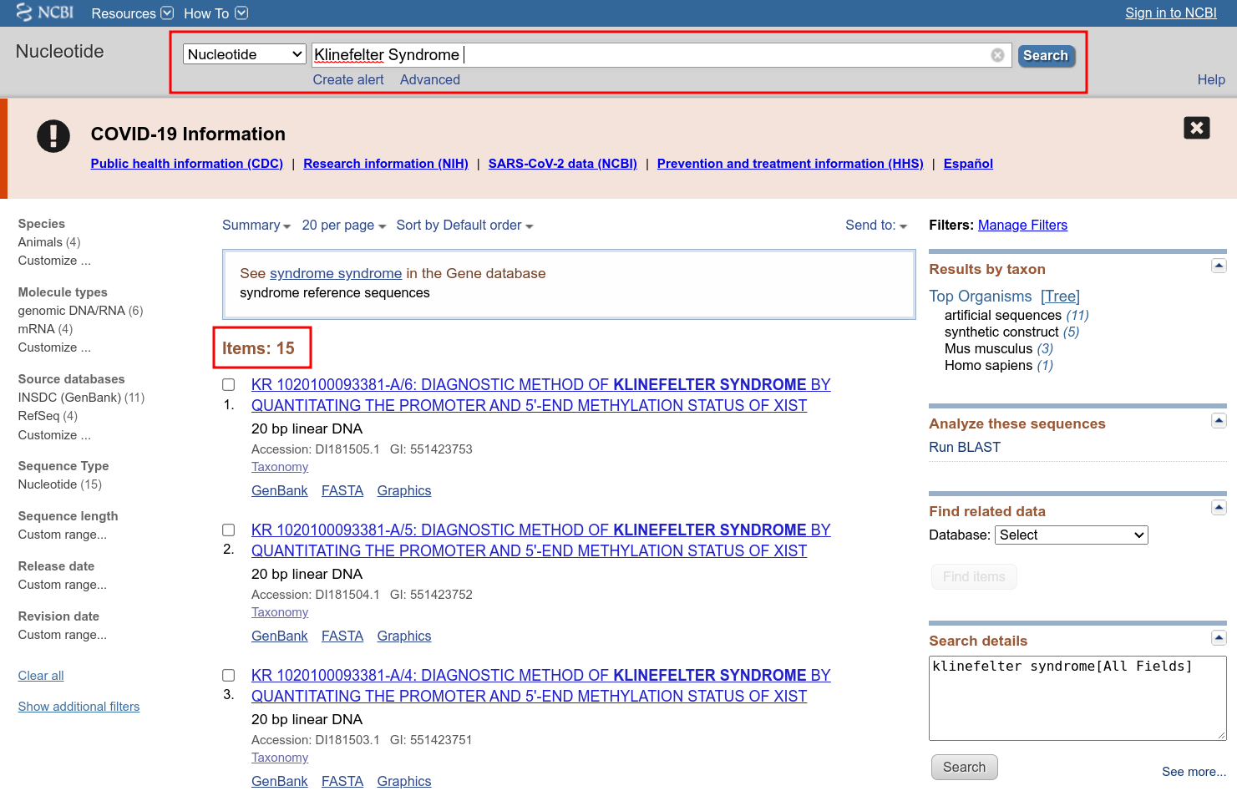
Fig2. Hit page with results for query Klinefelter syndrome

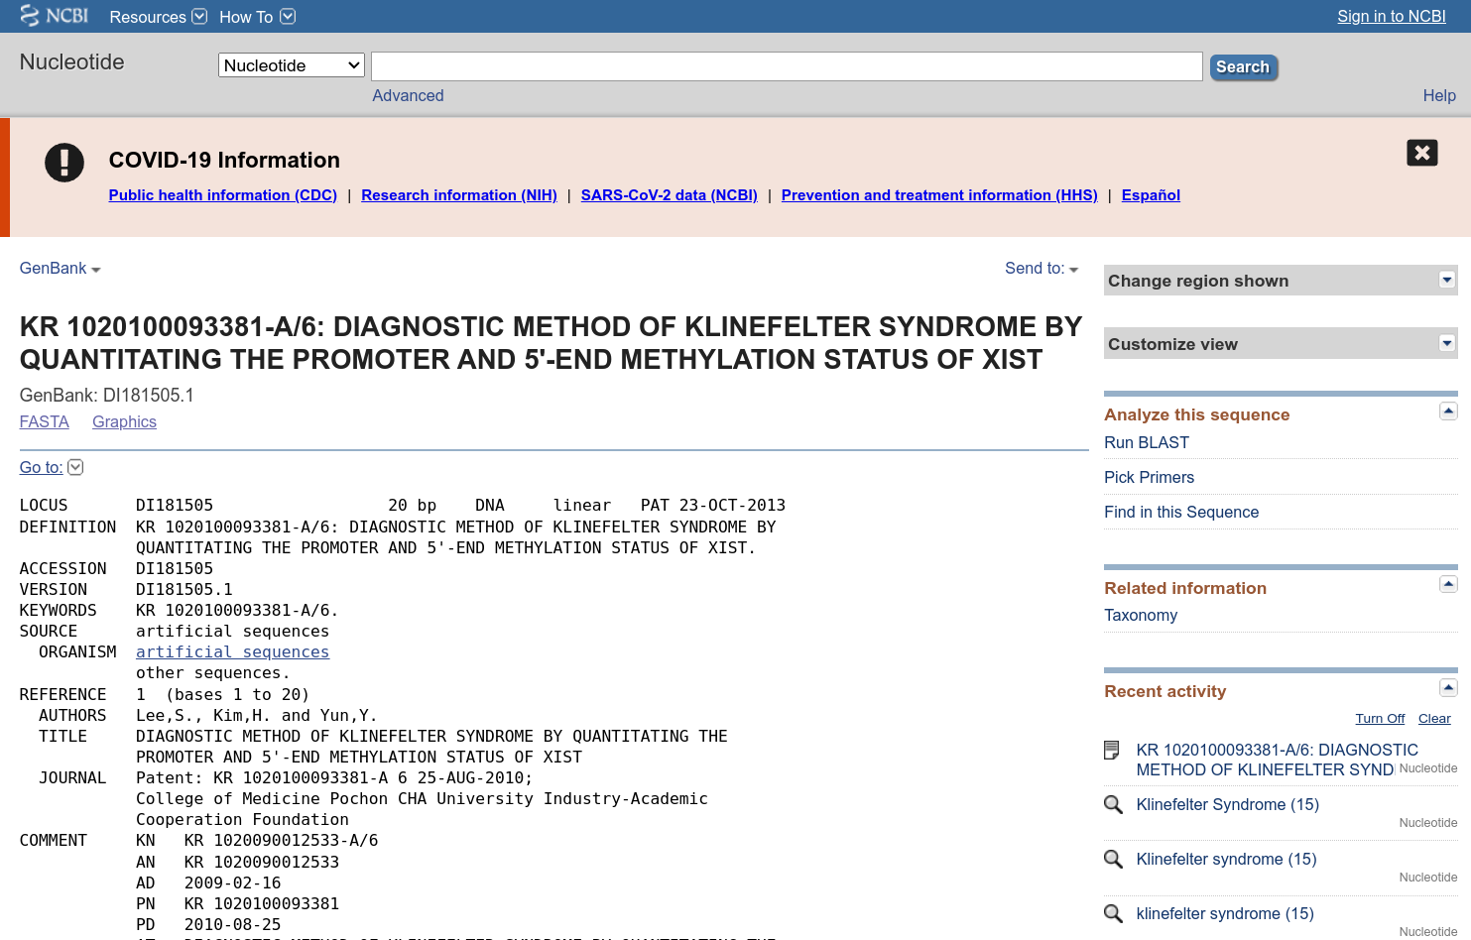
Fig3. Result page for query Klinefelter syndrome in GenBank [KR 1020100093381-A/6]
Fig4. Header of result for query Klinefelter syndrome [KR 1020100093381-A/6]

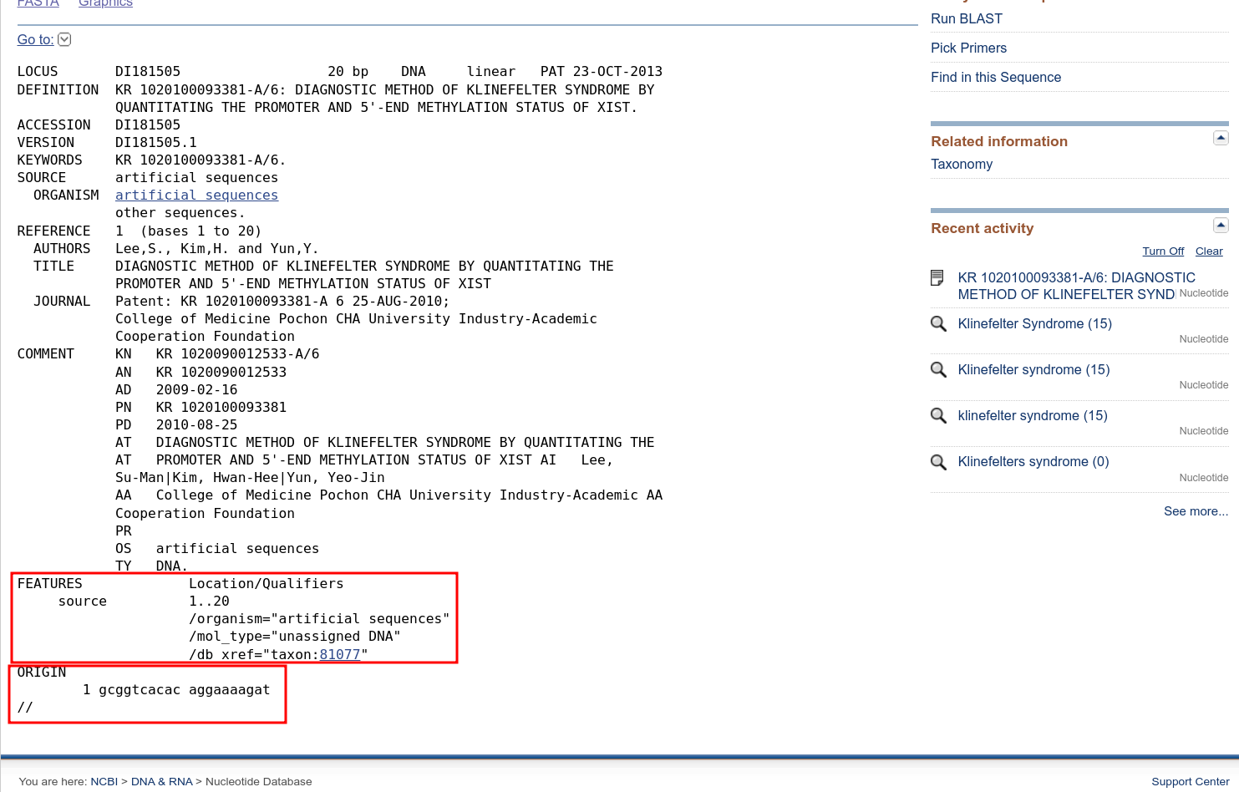
Fig5. Result page of query Klinefelter syndrome in GenBank with Features and Origin shown
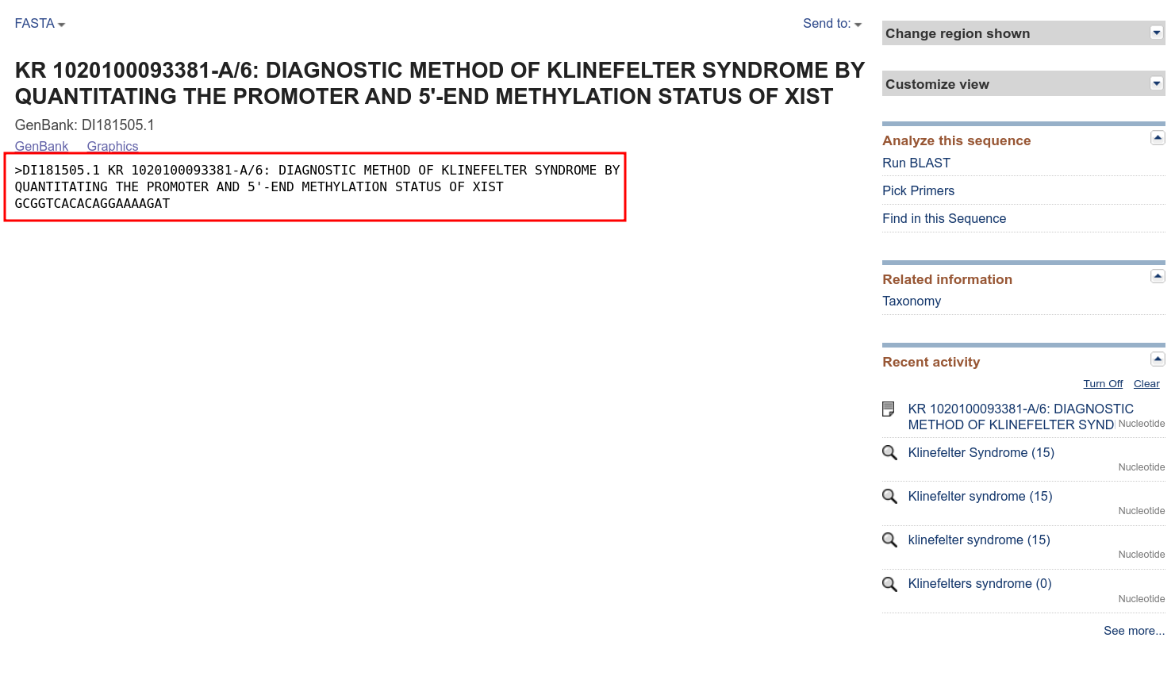
Fig6. FASTA sequence of Result of query Klinefelter syndrome in GenBank [KR 1020100093381-A/6]

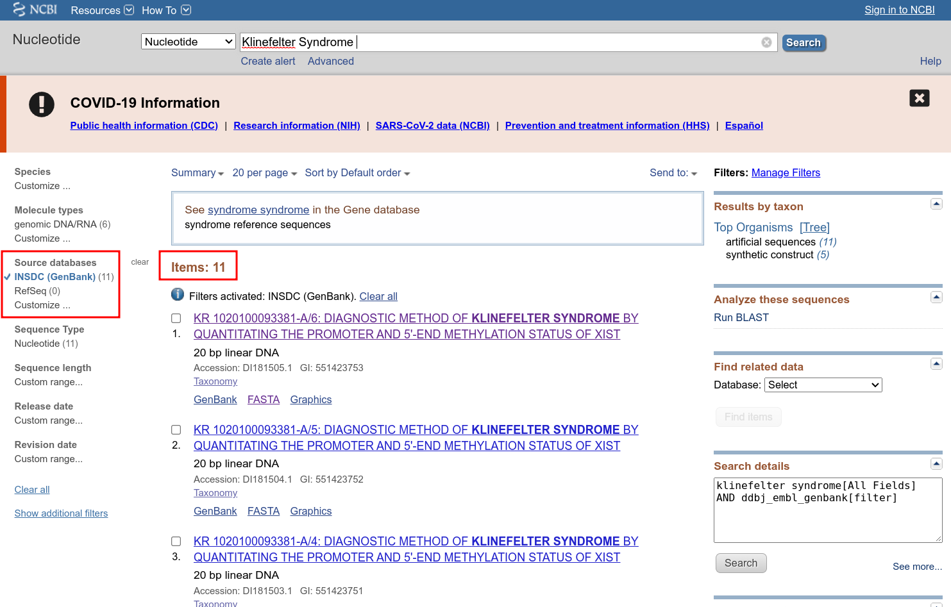
Fig7. Hit page for Klinefelter syndrome in GenBank with limit options and refined results

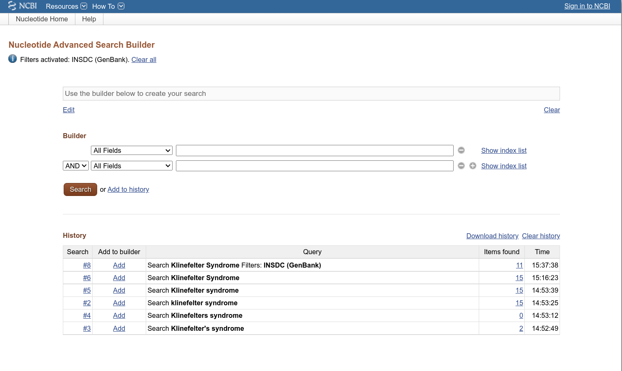
Fig8. Advanced search builder for Query Klinefelter Syndrome in GenBank

Conclusion:

GenBank is an amazing tool integrated within NCBI to make the querying of nucleotide sequences easy and accesible. The dataset is vast and depending on the query thousands of results can be poured over in a very short amount of time.

According, to the current time GenBank also provide detailed information about the release and notifications of upcoming changes in GenBank.

Result:

Sr. No. | Resource | Result
1 | GenBank | 15

References:
- https://www.ncbi.nlm.nih.gov/genbank/
- https://www.ncbi.nlm.nih.gov/nuccore/?term=Klinefelter+Syndrome
- https://www.ncbi.nlm.nih.gov/nuccore/DI181505.1
- https://www.ncbi.nlm.nih.gov/nuccore/DI181505.1?report=fasta

WEBLEM 3b
Introduction to Nucleic Acid Sequence Database

Aim:

To study the genes involved in the causation of Klinefelter’s syndrome using EMBL-EBI Database.

Introduction:

The query taken for EMBL-EBI is “Klinefelter’s syndrome”. Klinefelter syndrome is a genetic condition that results when a boy is born with an extra copy of the X chromosome.

Klinefelter syndrome is a genetic condition affecting males, and it often isn't diagnosed until adulthood. Klinefelter syndrome may adversely affect testicular growth, resulting in smaller than normal testicles, which can lead to lower production of testosterone. The syndrome may also cause reduced muscle mass, reduced body and facial hair, and enlarged breast tissue.

The effects of Klinefelter syndrome vary, and not everyone has the same signs and symptoms. About 3% of the infertile male population have Klinefelter syndrome.

Methodology:
- Open Homepage of EMBL-EBI (URL-https://www.ebi.ac.uk/)
- Enter Search query (Klinefelter’s syndrome)
- Interpret the result and find the needed data.

Observation:

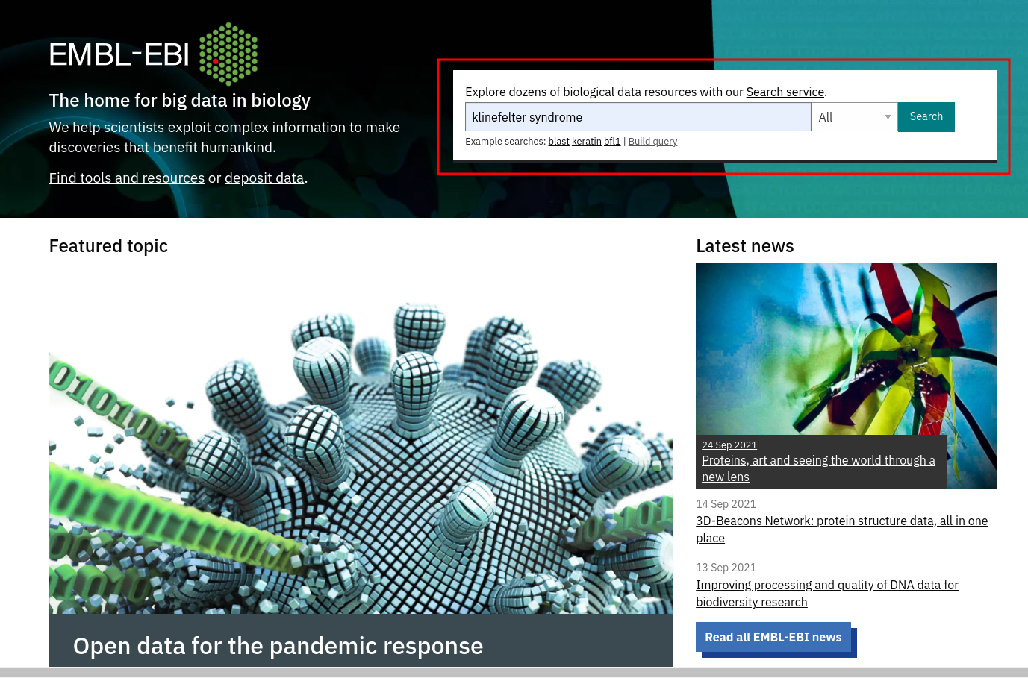
Fig1. Homepage of EMBL with query Klinefelter entered in the search bar

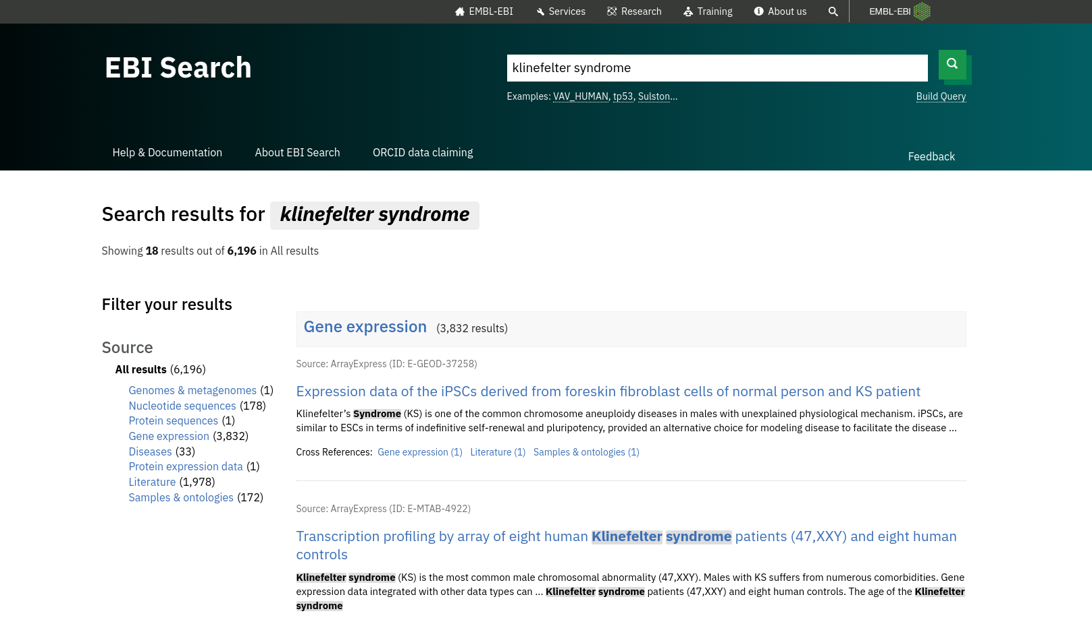
Fig2. Hit page of EMBL for query Klinefelter Syndrome

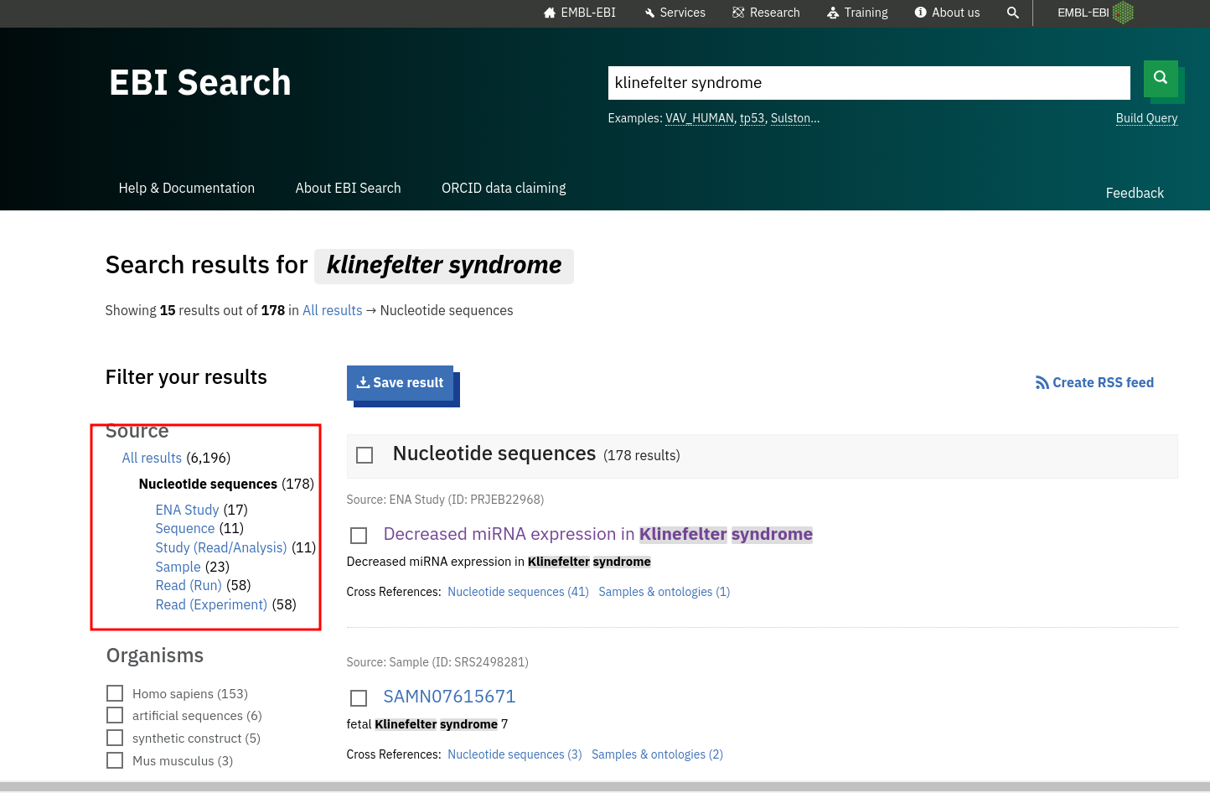
Fig3. Hit page of nucleotide sequences for Klinefelter syndrome

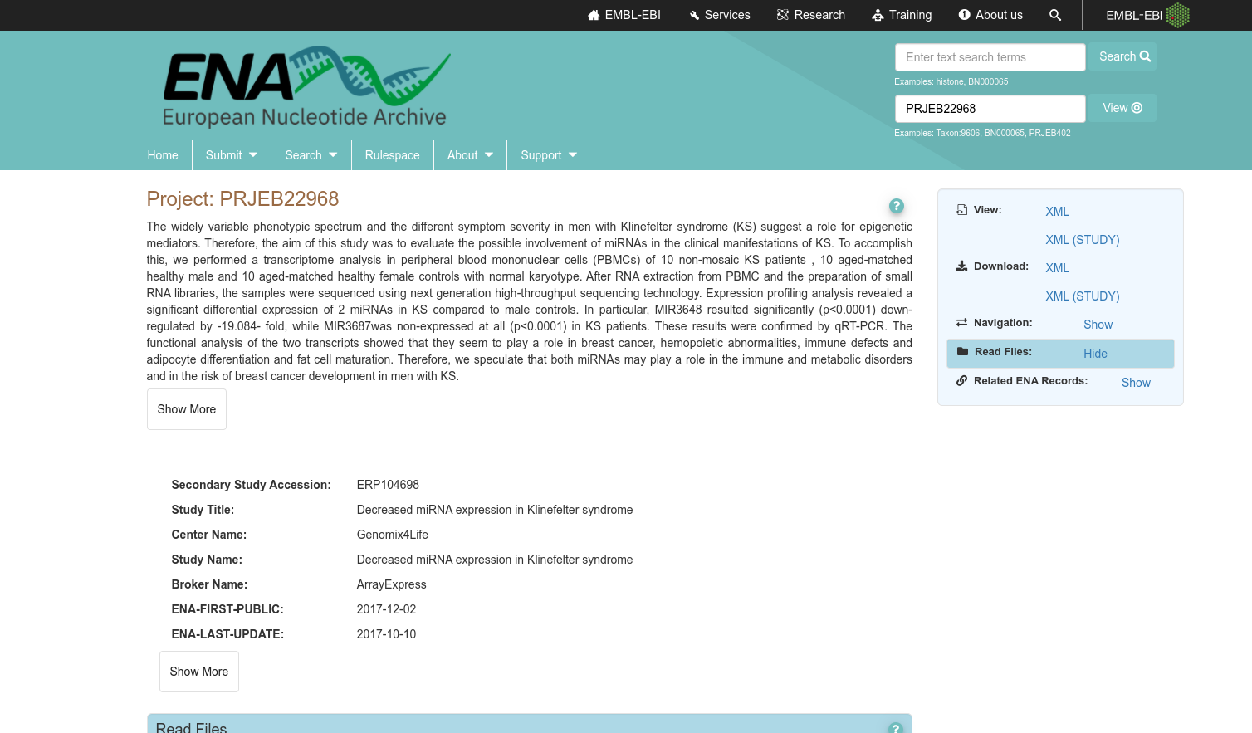
Fig4. Result page of nucleotide sequences for Klinefelter’s syndrome [Project: PRJEB22968]

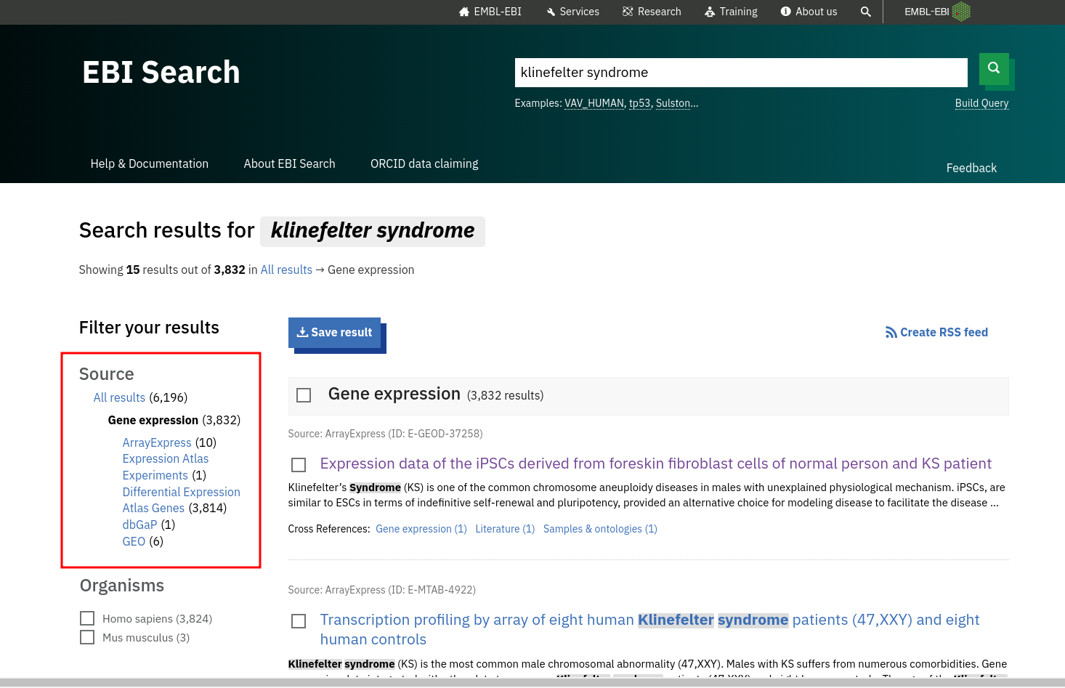
Fig5. Hit page of Gene expression for Klinefelter Syndrome

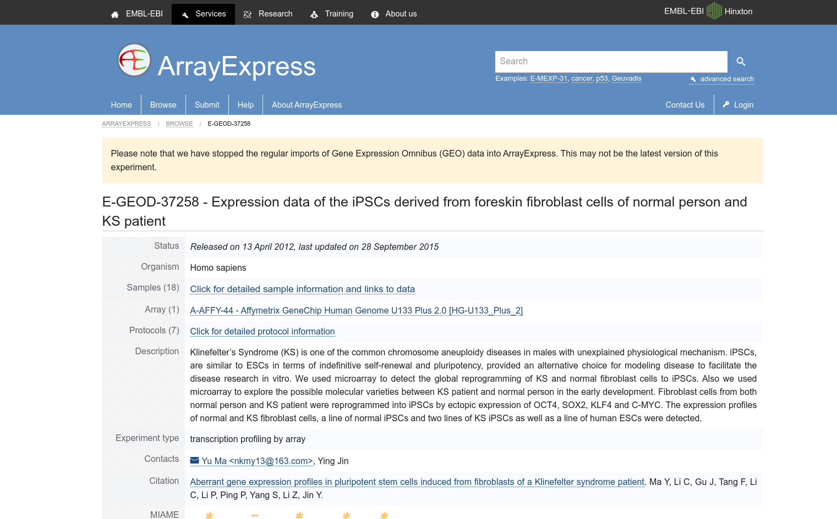
Fig6. Result page of Gene Expression for Klinefelter Syndrome [E-GEOD-37258]

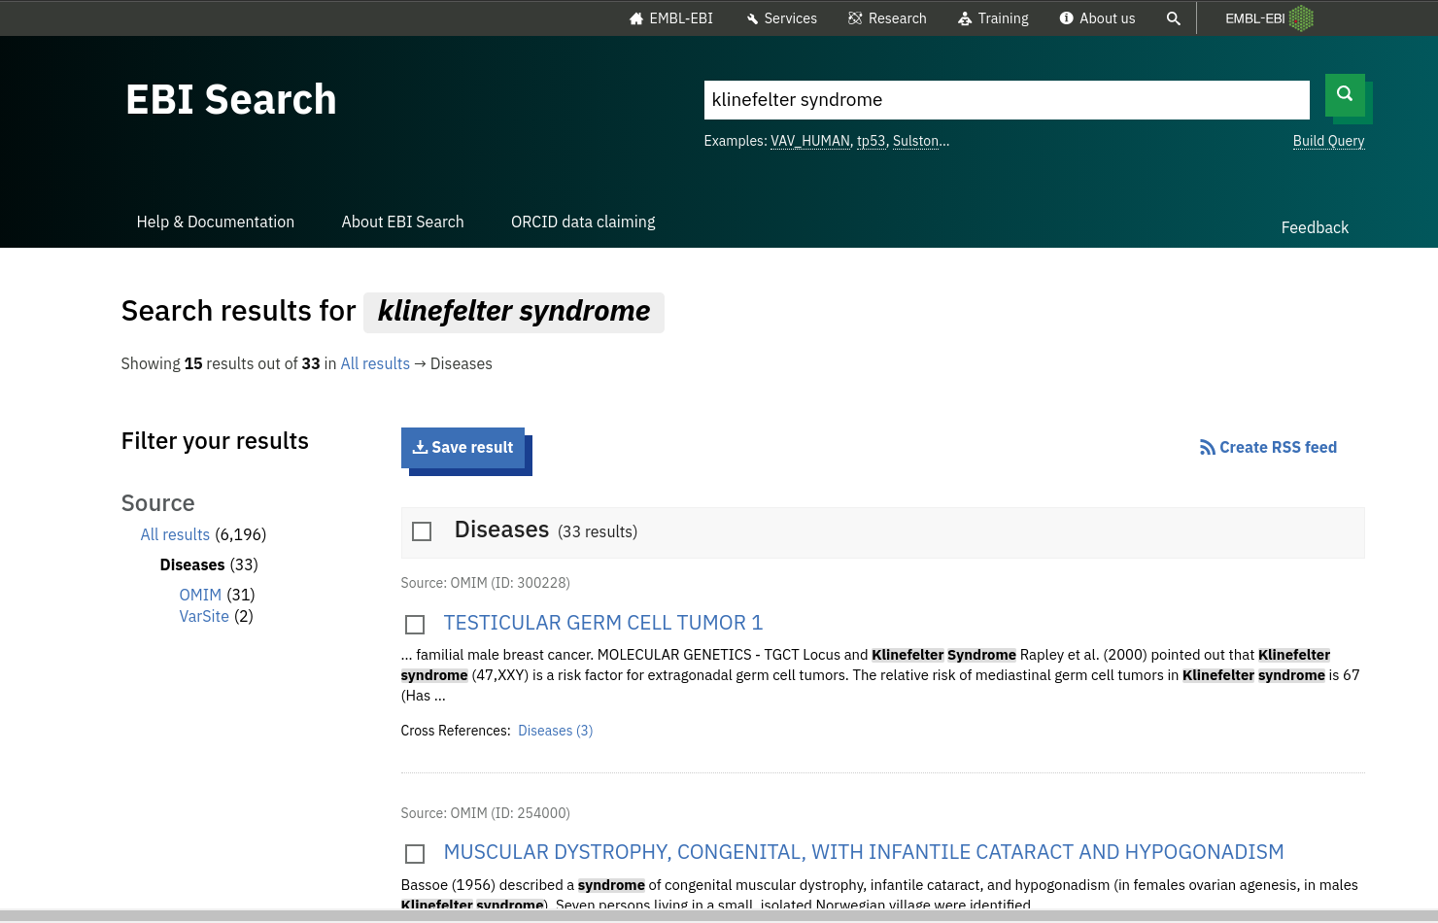
Fig7. Hit page of Diseases for Klinefelter’s syndrome

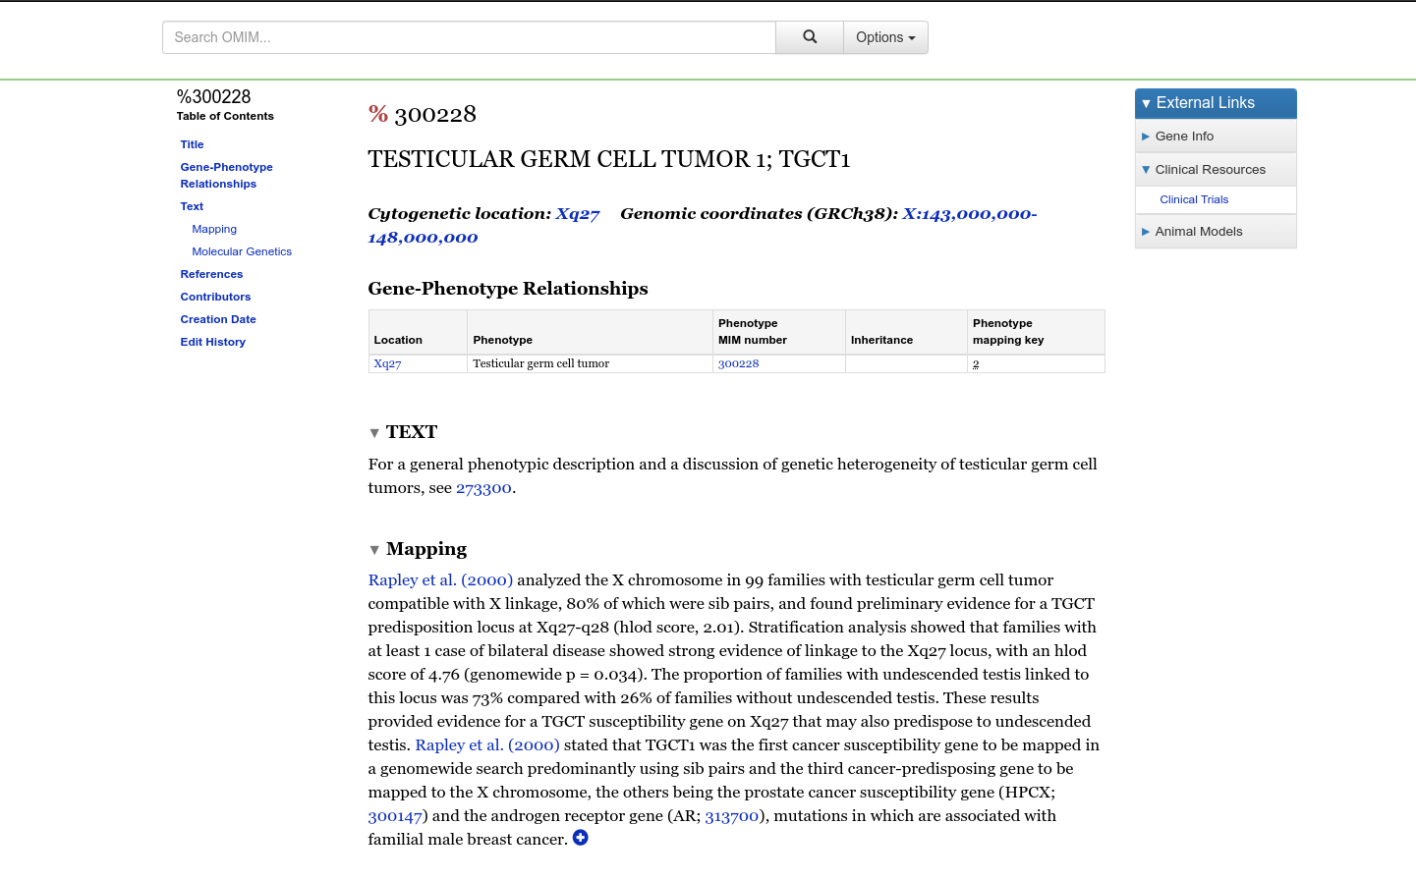
Fig8. Result page of Diseases for Klinefelter Syndrome [TESTICULAR GERM CELL TUMOR 1; TGCT1]

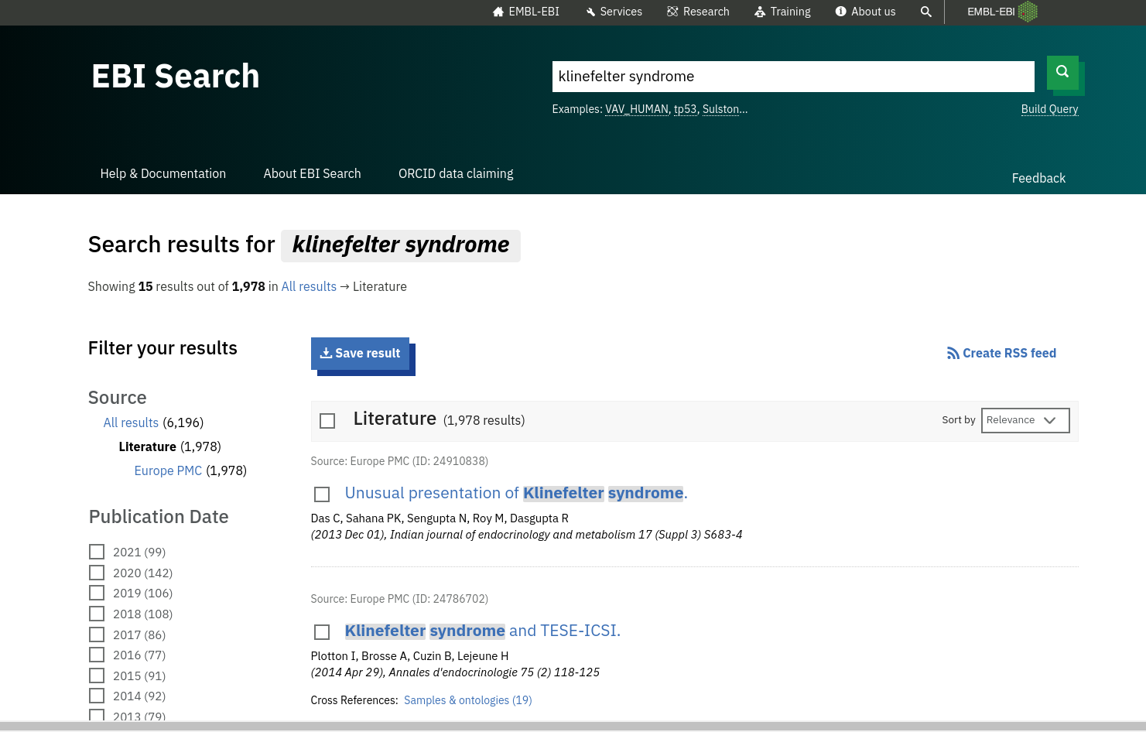
Fig9. Hit page of literature for Klinefelter’s Syndrome

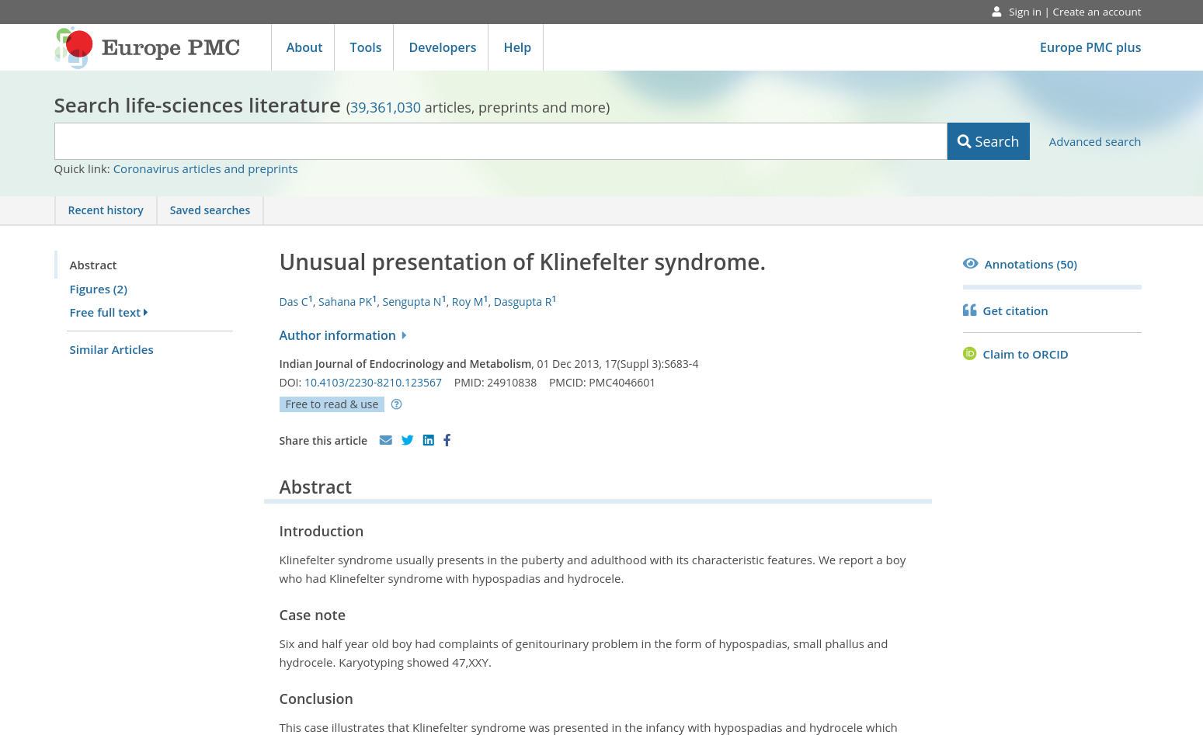
Fig10. Result page of Literature for Klinefelter’s syndrome [Unusual presentation of Klinefelter syndrome]

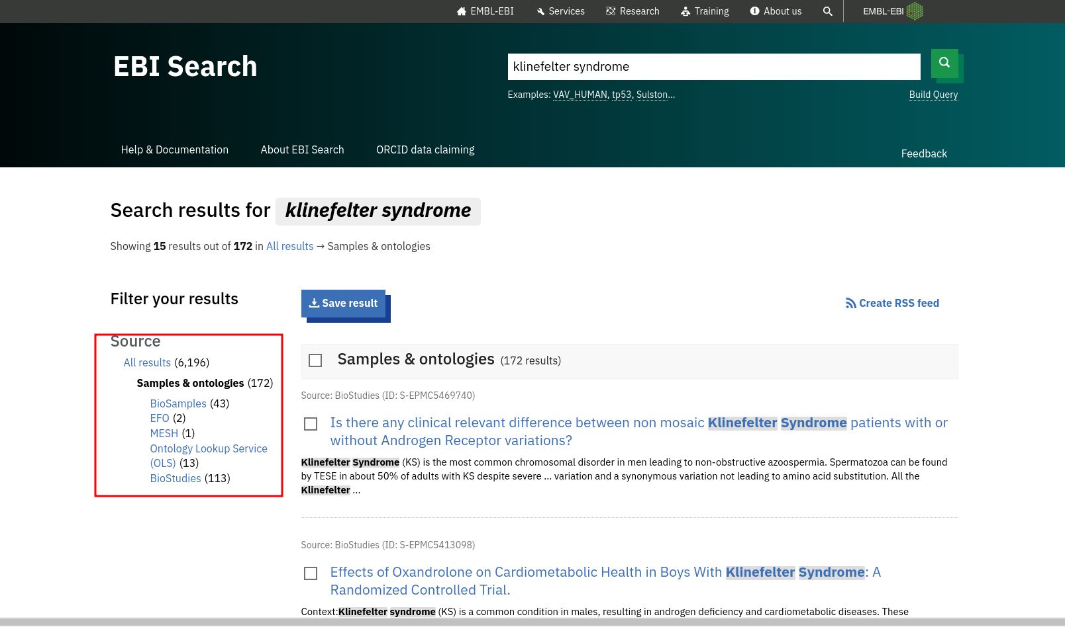
Fig11. Hit page of Samples and entologies for klinefelter’s syndrome

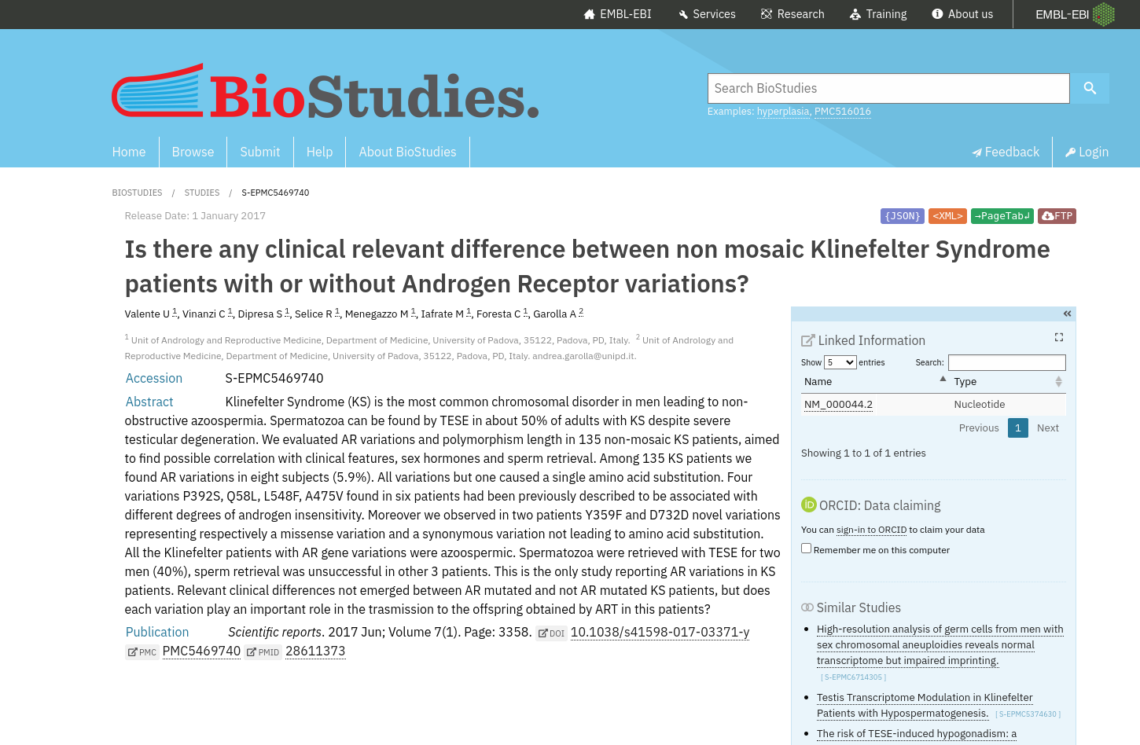
Fig12. Result page of Samples and entologies for Klinefelter’s Syndrome [S-EPMC5469740]

Conclusion:

EMBL provides a big combination of databases to choose from just like NCBI does. We can use it to found almos all kinds of relevant information related to research topic

Results:

Sr. No | Resource | Results
1 | Nucleotide Sequences | 178
2 | Gene Expression | 3832
3 | Diseases | 33
4 | Literature | 1978
5 | Samples and entologies | 172

References:
- https://www.ebi.ac.uk/ebisearch/search.ebi?query=klinefelter%20syndrome&db=allebi&requestFrom=ebi_index
- Nucleotide Sequence
  - https://www.ebi.ac.uk/ebisearch/search.ebi?db=nucleotideSequences&query=klinefelter%20syndrome
  - https://www.ebi.ac.uk/ena/browser/view/PRJEB22968?show=reads
- Gene Expression
  - https://www.ebi.ac.uk/arrayexpress/experiments/E-GEOD-37258
- Diseases
  - https://www.ebi.ac.uk/ebisearch/search.ebi?db=diseases&query=klinefelter%20syndrome
  - https://www.omim.org/entry/300228
- Literature
  - https://www.ebi.ac.uk/ebisearch/search.ebi?db=literature&query=klinefelter%20syndrome
  - https://europepmc.org/article/MED/24910838
- Samples and entologies
  - https://www.ebi.ac.uk/ebisearch/search.ebi?db=ontologies&query=klinefelter%20syndrome
  - https://www.ebi.ac.uk/biostudies/studies/S-EPMC5469740

WEBLEM 3c
Introduction to Nuclei Acid Sequence Database

Aim:

To study the genes involved in the causation of Klinefelter’s syndrome using DDBJ Database..

Introduction:

The query taken for DDBJ is “Klinefelter’s syndrome”. Klinefelter syndrome is a genetic condition that results when a boy is born with an extra copy of the X chromosome.

Klinefelter syndrome is a genetic condition affecting males, and it often isn't diagnosed until adulthood. Klinefelter syndrome may adversely affect testicular growth, resulting in smaller than normal testicles, which can lead to lower production of testosterone. The syndrome may also cause reduced muscle mass, reduced body and facial hair, and enlarged breast tissue.

The effects of Klinefelter syndrome vary, and not everyone has the same signs and symptoms. About 3% of the infertile male population have Klinefelter syndrome.

Methodology:
- Open Homepage of DDBJ (URL-https://www.ddbj.nig.ac.jp/index-e.html)
- Navigate to Services > Getentry
- Enter Search query (Accesion ID of a paper based on Klinefelter Syndrome)
- Interpret the result and find the needed data.

Observations:

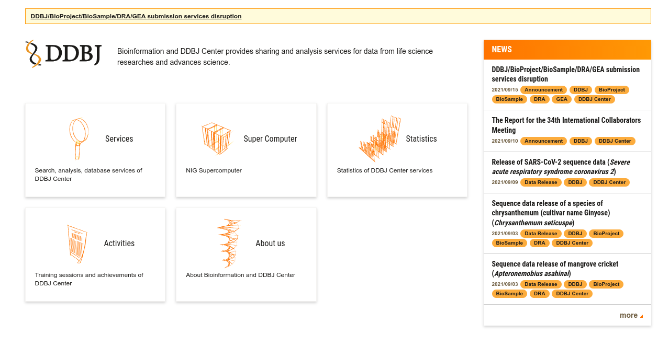
Fig1. Homepage of DDBJ
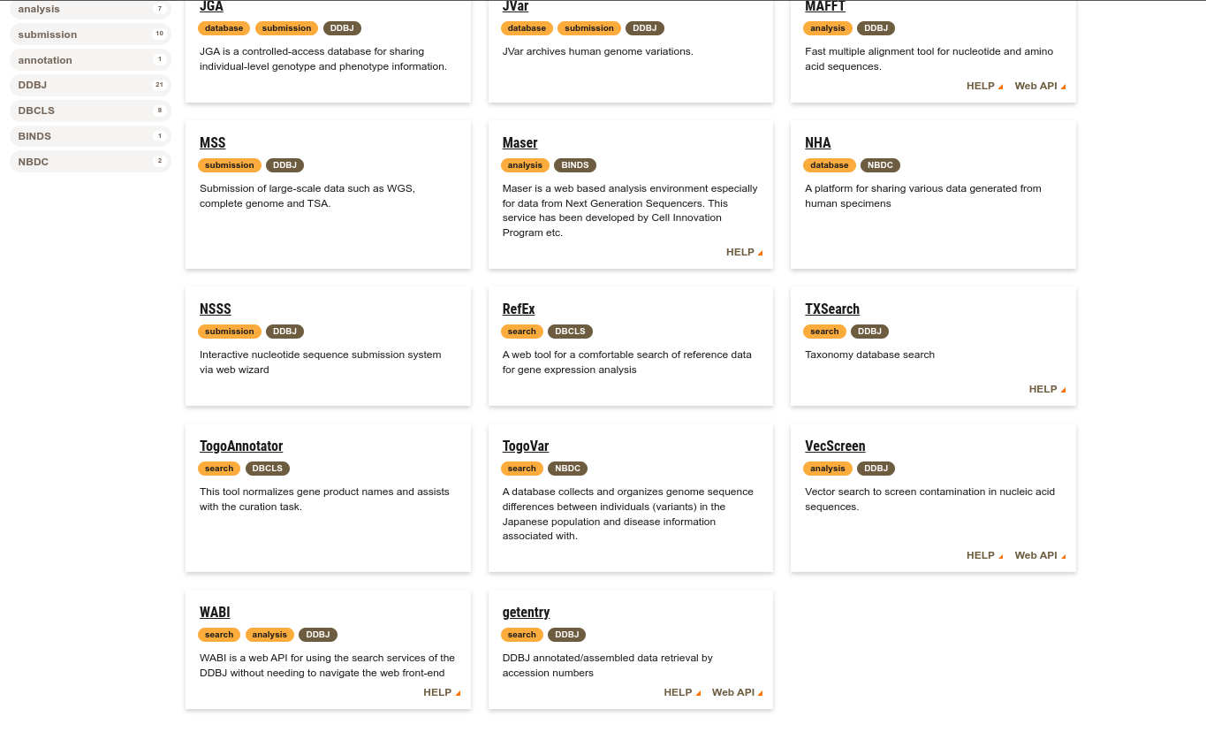
Fig2. Services page of DDBJ with gententry highlighted

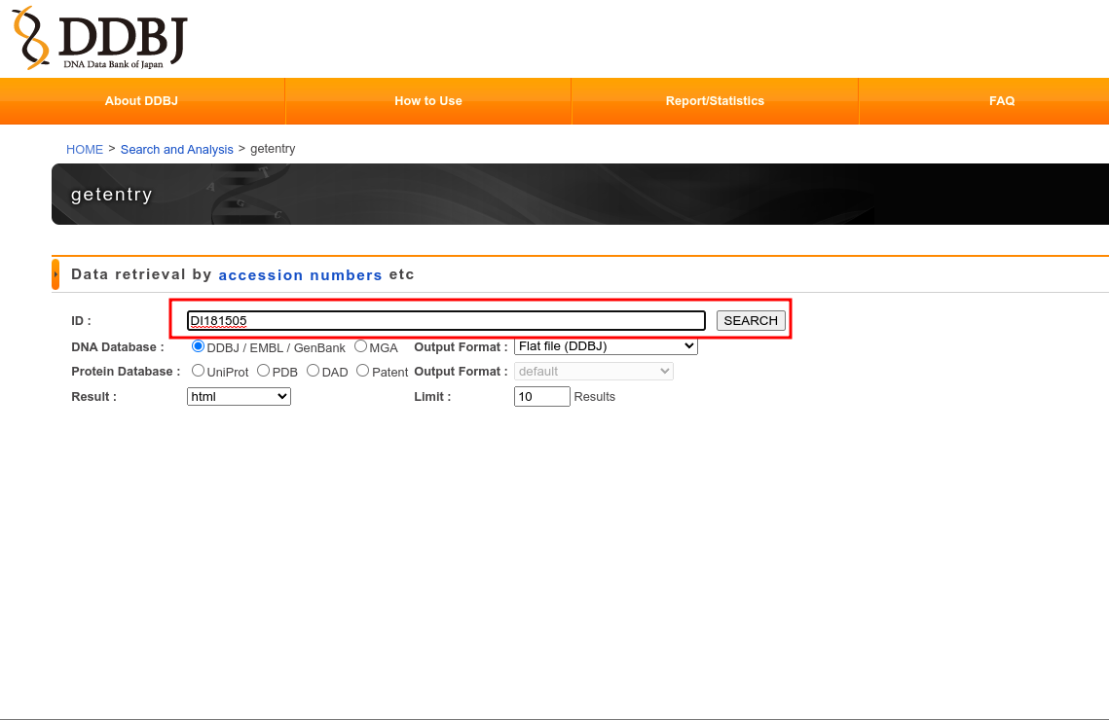
Fig3. Getentry page of DDBJ with accession ID of result from GenBank [Weblem 3a] entered
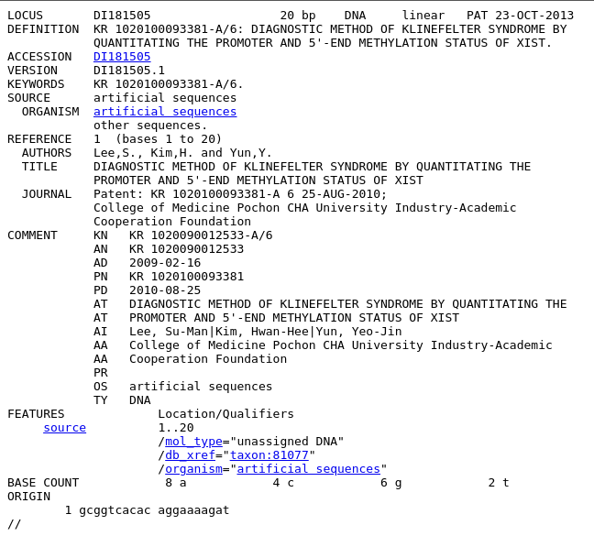
Fig4. Result page with Header, Features and Origin Highlighted for Klinefelter Syndrome
HEADER
FEATURES
ORIGIN

Conclusion:

DDBJ provides complete data on a nucleotide sequence based on the accesion ID of the sequence. It is an easy and quick way to cross check and identify the necessary data

Result:
On firing the accession ID for the Klinefelter Syndrome sequence was retrived

References:
- https://www.ddbj.nig.ac.jp/index-e.html
- https://www.ddbj.nig.ac.jp/services/index-e.html
- http://getentry.ddbj.nig.ac.jp/top-e.html
- http://getentry.ddbj.nig.ac.jp/getentry/na/DI181505/?format=flatfile&filetype=html&trace=true&show_suppressed=false&limit=10

